Business Requirements Document (BRD)
for
Healthcare Portal
Version 2.0 [draft]
Prepared by

Project Sponsor: Mr. Sadiq

Document Number: D-002/HC001/BRD
Version: 0.2

Last Updated: 6th November 2010
Creation Date: 11th October 2010

Table of Contents

Table of Contents 2
1. Introduction 4
1.1. Document Purpose 4
1.2. Intended Audience 4
1.3. Project Background 4
1.4. Purpose of the Business Requirements 5
1.5. Business Goals/Objectives to be achieved 6
1.6. Benefits/Rationale 6
1.7. Stakeholders 6
1.8. Dependencies on existing systems 7
1.9. References 7
1.10. Assumptions 7
2. Requirements Scope 7
2.1. Targeted Languages of the current system 10
2.3. Information Architecture (Medical Tourism Portal) 10
2.4. Information Architecture (Portal for India) 12
2.5. Information Architecture (Admin Intranet Area) 14
3. Functional Requirements 14
3.1. User Profiles Specification (Applicable to Tourist portal and Portal for India) 14
3.2. SMS Functionality 17
3.3. PMR Functionality 17
3.4. MAP Functionality / Google MAP API integration 17
3.5. Virtual office / Clinic management application 18
3.6. Advertisement / branding / rotating banner management 19
3.7. Jobs functionality 19
3.8. Search / Advance search 20
3.9. Communication / Work flows 20
3.10. Building consumer database 20
3.11. Manage database for Pharmacists/Drug stores/ Diagnostics centers and locate them in Google Map 20
3.12. Community services / Corporate social responsibility 20
3.13. Connect (Consumer, Service provider (Doctor, Drug store, Diagnostic center) 21
3.14. Interactive Forms 21
3.14.1. Service Request 21
3.14.2. Contact us 22
3.14.3. Feedback 22
3.14.4. Publish Basic Services (Health Tourist Portal) 23
4. Data Requirements (Medical tourist portal) 24
4.1. Data Architecture / Metadata 24
4.2. Entity Relationship Diagram 26
4.3. Data Volumes 26
4.4. Data Retention and Archiving 26
4.5. Privacy Implications 26
4.6. Data Definition Reports 27
4.6.0. Entity Definition Report 27
5. Data Requirements (Portal for India) 28
5.1. Data Architecture / Metadata (for Portal in India) 28
5. Security Requirements 28
5.1. Authentication 28
5.2. Availability Requirements 29
5.3. Usability Requirements 30
5.4. System Help Requirements 30
5.5. Performance Requirements 31
5.6. Scalability Requirements 31
5.6.1. User Scalability 31
5.6.2. Application Scalability 31
6. Interface Requirements 31
6.1. User Interface Requirements 31
6.2. System Interface Requirements 31
7. Project Plan and Delivery Schedule 32
7.1 Project Schedule 32
7.2 Project Schedule 32
8. Communication Plan 33
8.1 Proposed Communication Plans 33
Revision Log 34
Appendices 34
Approval 35

Introduction

Document Purpose

The purpose of this document is to describe business requirements of Healthcare portal completely, accurately and unambiguously in Technology-independent manner. All attempts have been made in using mostly business terminology and business language while describing the requirements in this document. Very minimal and commonly understood Technical terminology is used. Use case / Designer approach is used in modeling the business requirements in this document.

Intended Audience

The main intended audience for this document are the business owners of the proposed system. This document should be readable by business owners of the proposed system. They must be able to verify that their business requirements have been documented here completely, accurately and unambiguously.

Data Architects, Application Architects and Technical Architects would also find the information in this document useful when they need to design a solution that will address these business requirements.

Since the requirements are documented here in Technology-independent manner, the end-users of the system should be able to comprehend the requirements fairly easily from this document.

Project Background

Medical tourism industry in India is growing rapidly and this industry is estimated at Rs. 1,950 cores (Source: Indian Express. Tue Oct 05 2010 http://www.indianexpress.com/news/--CWG-windfall-awaits-medical-tourism--/692950))

For Indian doctors, western shores could be greener. But for an increasing number of foreign patients, Indian hospitals are fast becoming their first choice. Over 1.5 lakh medical tourists travelled to India in 2002 alone, bringing in earnings of $300 million.
Since then, the number of such travelers has been increasing by at least 25% every year. A CII-McKinsey report projects that earnings through medical tourism would go up to $2 billion by 2012. (Source: Times of India. Apr 4, 2008 http://timesofindia.indiatimes.com/india/Medical-tourism-booming-in-India/articleshow/2924252.cms)
People rush to India for treatment because it is 35 to 40% lesser than the treatment cost in USA. It is not just cost, India has got specialist around the world and world eminent Doctors/Hospitals where there to provide all services to the patient. English speaking is another advantage where patients can address/communicate without any difficulties.

India is one of the most favorable tourist destinations in the world. Medical treatment combines with tourism would give an added advantage to the customer.

There are treatments like dental and cosmetic surgery which are categorized as non-life threat are mostly not covered under the health insurance. These treatments are charges exorbitant
price in USA. A person can get world class treatment in India and would like to take advantage of India’s ancient tradition and explore various places and still save huge sum.

<ABC> healthcare is an internet web portal to provide not-health risk medical tourism services to the people of USA and build a database of Hospitals, Clinics, Doctors and Facilities provided by each Hospital/Clinic in India.

The portal would potentially glow and come to full blown services in due course of time; however to start with it is targeted to provide medical tourism services like Dental and Cosmetology. Towards building of database, can start with major metropolitan cities like Hyderabad, Bengaluru, Delhi, Mumbai, Kolkata, Chandigarh, Chennai, Pune, Ahmedabad, Goa and consider to be phase-1 of the project.

Purpose of the Business Requirements

This section describes the purpose of the Business Requirements.

Business requirements for major enhancements to an existing application.

Business requirements for new application development.

Business requirements for replacement application development.

Business requirements for a request for proposals (RFP).

Business Goals/Objectives to be achieved

The objective of this portal is to attract people from USA to visit India as a medical tourist. Also a database of Doctors, Hospitals, Clinics and facilities would help common people to search and get right treatment. People would have an opportunity to check various alternates available to them and compare price of one with the other.

- Generate 100+ number of leads and convert into 50 number of business opportunity in a month
- Build database of 10,000 number of hospitals; 25,000 number of clinics; 250,000 number of Doctors in a phased manner (city wise)
- Targeted cities in India
- Compare services of one with other in a similar category
- Feature various tourist and visiting places in India
- Feature hotels and places of accommodation
- Showcasing US office address and a person attending queries
- Channelizing contacts and signing MoUs with various corporate hospitals
- Beta release target date
- A panel of doctors in the company board would give an added advantage

Benefits/Rationale

This section describes the major benefits to be achieved with the implementation of the Business Requirements.

Stakeholders

- Project sponsors
- Hospitals/Clinics in India
- Doctors in India
- Medical tourists (Customer)
- Patients in India
- Web-site visitors
- Pharmaceutical Companies
- Diagnostic Centers
- Patients in general
- Job seekers
- Employers

Dependencies on existing systems

This section describes the dependencies between the Application for which these Business Requirements are written and the other existing applications/systems.

Not applicable

References

Project Charter Ver.02

Assumptions

This section describes major assumptions that were made prior to or during the Business Requirements gathering and documentation.

Requirements Scope

This section shows what business functionality is in scope and out of scope for Implementation. In Use case approach, the out of scope Use cases are indicated in a separate boundary box. In Oracle Designer approach the out of scope Functions are shown in grey coloured boxes.

- Public facing websites (Health tourist portal and Indian portal) should have world class design templates.

Functionally there are two separate public facing websites. One is to promote health tourists and the other is for In

- Content of the website would change depending upon the targeted audience and managed through country IP (i.e. different look and feel for USA and Indian visitors). Virtually it is two different websites.
- All the contents are to be managed through a password protected admin intranet (to publish formatted text, images, videos
- Admin intranet will have various user level to access/not to have access to certain data
- Publish basic services – identified in the 1st phase (non life risk medical tourists)
- Publish ancillary services (Visiting places, hotels etc.)
- Customer can compare services and pricing on the portal
- Customer can submit an enquiry form which is considered to be a business lead
- All the communication with the customer should be managed through the admin intranet
- Extensive search facility (simple and advanced search)
- Integration with Google Map API (Should be the first of its kind information) Facility to update by the individual visitor like updating address/location in the Google map.
- Jobs section (Post jobs, Search jobs related to healthcare services)
- Branding and advertising by various service providers (Listing of hospitals/clinics, Listing of doctors, Pharmaceutical companies, New product releases, related services like Ambulance, Suppliers etc.)
- Virtual office for Doctors – Online appointment, sync calendar in smart phones (This may attract some Doctors to be part of this initiative).
- Clinic management software – SaaS software to manage small clinic/independent doctors
- Building consumers database which would help in the future to market
- News feeds
- Email integration
- SMS integration
- Community services/Corporate Social Responsibility (If the customer is poor and could not locate a doctor, we will help them locating right doctor)
- PMR (Personal Medical Record)
- Manage data bases of Pharmacists/Drug stores and locate them in Google Map
- Connect (Consumer, Service providers (Doctors, Drug stores, Diagnostic centers etc..)

- Website.

The website contains a home page describing the purpose and navigational links to other sections. Each navigation link takes the web site visitor to a separate page. Some pages like (About us, Services, Contact us, Why we) and navigations links described in the respective IA.

Typical Website flow – Tourist portal:

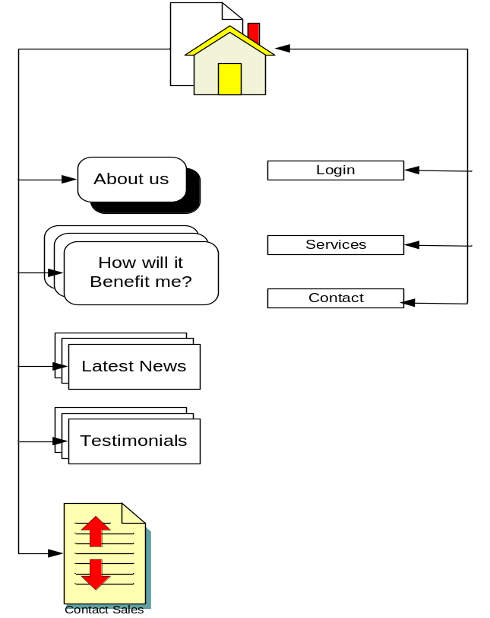

Targeted Languages of the current system

The public facing website of the Health tourist portal contents to be available in the following languages:

- English
- Spanish

English is the default language when website is open. There would be an option where user can change the language.

All options, menus, titles, labels and on-screen messages are to be changed to “Spanish” when the user select language option.

It should be an easy to use admin interface to create/update language equivalents for all relevant sections.

English is the primary language for the Indian portal.

Information Architecture (Medical Tourism Portal)

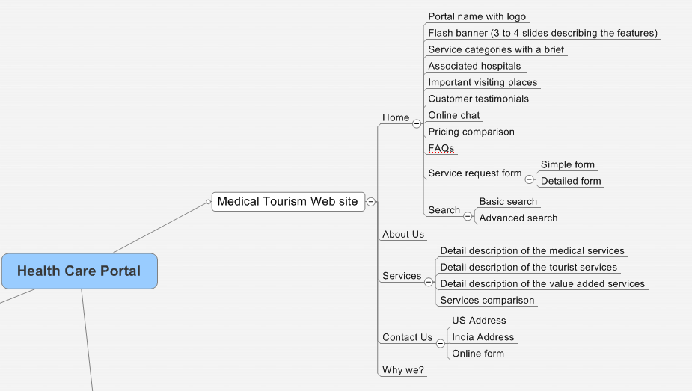

Website Layout (Medical tourist portal)

Logo
Website name/title
Live Chat section
Banner section to explain the Website / services features

1
2
3
4
Visiting Places in India
Compare services section
Service categories section
Client testimonials
Latest News
Copyright _____ Privacy | Disclaimers | Terms of use

Information Architecture (Portal for India)
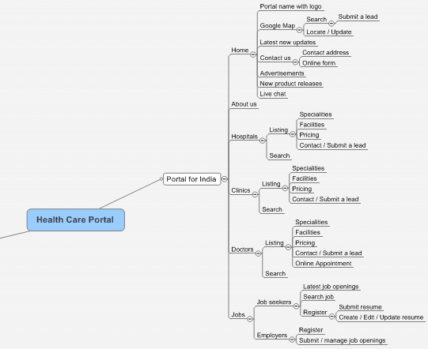

Website Layout (Portal for India)

Logo
Website name/title
Live Chat section
Submit
Hospitals
Clinics
Doctors
Diagnostics
Jobs
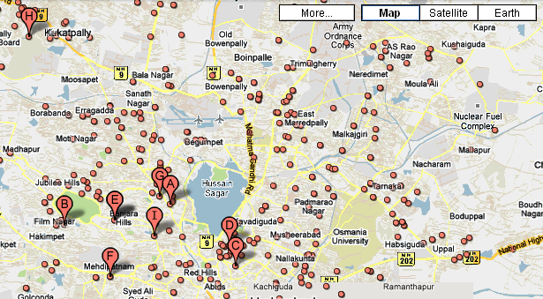

Copyright _____ Privacy | Disclaimers | Terms of use
Search Here
Ex. General Physician in Hyderabad, Abids
Switch to Advance Search
Space for Ad. banner
Space for new products released
Space for displaying comparisons

Information Architecture (Admin Intranet Area)

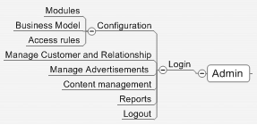

Functional Requirements

User Profiles Specification (Applicable to Tourist portal and Portal for India)

This section describes all the Actors and their profiles within the context of the Business Requirements being documented. An Actor is a person, organization or an external system/sub-system/program that has interactions with the Application. Actors, by definition, are external to the system with which they are having interactions. Actors have goals that are achieved by use cases. Typically, Actors have behaviour and are represented by the roles they play in the use cases. An Actor stimulates the system by providing input and/or receiving something of measurable value from the system.

Super Admin User:

Super Admin user has control over the complete system and can manage to create other users, groups, privileges and required master data.

The functionality of the complete application is modularized and access to each module is set by the application’s access control matrix.

Typical user access control matrix:

Roles --> | Admin
 | Add | Edit | Del | View
Manage Groups | Y | Y | Y | Y
Manage Users | Y | Y | Y | Y
Manage Business parameters | Y | Y | Y | Y

Super admin can inactivate certain Groups/Users/Features for some reason before deleting permanently. The user having admin privilege can activate or inactivate a record.

A data view list can have the option to see Active and Inactive records.

Accesses to individual activity are fixed as per the user classification and role.

Super Admin User

User Name

Password
OK
Cancel



Group and User Management
Manage Business Parameters
Content Management
Client relationship management

Communication Management

Administrator:

Administrator is another user who inherits some controls from the super admin to perform certain activities. Generally admin user has all the rights of “Add/Edit or Delete a record. There can be multiple admin users.

Content Developer:

Content developer is another user who generally create new contents/edit the content but does not have right to delete permission. Content created or edited would not be published until it is has be reviewed or approved by the Publisher.

Content Publisher:

Content publisher will review, approve or disapprove any content to be published in the public area.

Website Visitor:

Any website visitor will have access to all the public contents published in the website. Website visitor can search and consume all services which are set as free services.

Registered User:

Registered users will have privileges to access certain private data and communicate with the service providers.

Customer:

Customer is a user who would have access to paid services.

SMS Functionality

- Able to configure at least 3 service providers API for sending SMS.
- Able to send bulk SMS by the website admin/users to the various stake holders.
- Able to configure in the Admin internet to send SMS for various activities (Example a new lead is received, confirmation to customer that his enquiry is recorded etc..)
- Registered users / customers can send SMS after login
- Able to allocate number of SMSs a customer can avail free and subscribe for more SMSs (mostly applicable for virtual office and releasing new products)

PMR Functionality

- Able to update demographics / personal records
- Able to update demographics of the family members
- Able to update Doctors information
- Able to upload prescriptions (as attachments)
- Able to update prescriptions as text
- Able to setup medication
- Able to setup alerts (Email and SMS) with regard to regular checkups, medicine and doses
- Able to share medical records with the doctor for a particular period with permissions (View only / View and Download)

MAP Functionality / Google MAP API integration

- Able to locate Doctors, Hospitals, Clinics, Drug Stores, Diagnostic Labs on a MAP.
- Display different icons for each category of information.
- Icons are updated through Admin intranet for each category of information.
- Able to display more information through a call-out when user point on a particular icon.
- Able to view more information in a separate page when user opted to know more about selected information.
- User can able to submit feedbacks to the site owner for any selected information.
- User can able to report any errors to the site owner for any selected information.
- The feedbacks / errors reported by the users are emailed/sms to the respective site admin/user.
- The feedback / reported errors are stored in the admin intranet.
- The user is reported back when the corrections are done or feedback are acknowledged.
- Visitors can add a location (Doctor/Hospital/Clinic/Medical store/Diagnostics) if they feel so by filling a small form. The Latitude and Longitude should be picked up automatically.
- The information submitted are stored separately for the admin to review and approve or disapprove.
- A message email/sms sent to the user who submitted when the admin approve / disapprove. If the admin disapprove the reason should be filled and intimated.

Virtual office / Clinic management application

- Application is based on SaaS (Software as a service) model
- Able to provide a separate area for each customer (Doctor/clinic) and accessed through a user name and password
- Each customer can sign-up to avail this facility
- Customer can opt-out this service by sending an email/calling to a site admin / support request.
- Admin can activate / inactivate this service for a customer
- Following are the facilities included in the Virtual office:
  - Customer (Doctor/Clinic) update their place of availability, timings for a particular period (Day, Time, Not available time etc..)
  - Visitors (Patients) can view the calendar or schedule an appointment
  - Customer to view the calendar and list of appointments
  - Customer can accept / reject one or all appointments for a day or period
  - Information goes to the patients when Doctor/Clinic accepted or rejected an appointment by email / sms
  - Record/update patient visits
  - Able to generate a bill for the services
  - Able to write a prescription for the patient
  - Able to generate a medical certificate for the patient
  - Able to recommend/order a diagnostics

- SaaS Architecture

            - Fully Shared DB Per Tenant

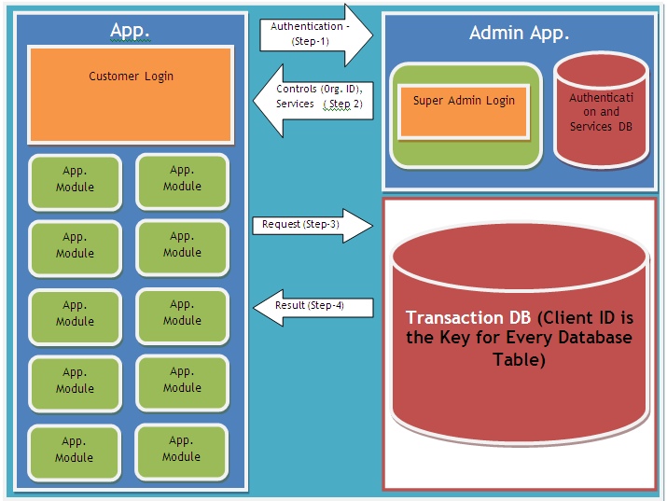

The proposed application should be deployed on SaaS platform. The application should take care of the following while designing the application.

- Performance
- Security
- Reliability
- Customization
- Integration
- Scalability
- Multi tenancy

There are two layers. DB layer and Application Layer. Organization ID is the key for all database tables (Master and transaction). Data is accessed from the application by providing Organization ID.

Every user is associated with an organization id. An organization can have many users. User ID is unique throughout the database.

There are two databases; one to store all data related to user, contains (username, password, organization id) for authentication and the other is database contains data related to application. GUID is used for organization id. Multiple organization data can reside in a single database or multiple of databases.

Advertisement / branding / rotating banner management

- Able to define the ad placements in various pages
- Able to define price for ad placements (ad size / duration / price)
- Able to update/upload ad content for a location with priority, number of impressions, time period etc..
- Able to manage the ad banners and content through admin area

Jobs functionality

- Able to search job openings by enter search text, experience/location.
- Able to respond/send resume for a job directly after login
- Able to publish list of recent jobs by function and location
- Able to publish top 10 employers with their logos. Display list of current job openings.
- Able to register and upload resume by the job seekers
- Able to login and update resume by the job seekers
- Employers to register and update job openings
- Employer login and search resumes
- Down load matching resumes for a particular post
- Email to job seeker when a new matching job is updated by the employer
- Email to employer when a new matching resume is updated by a job seeker.
- Block resumes to be viewed by certain companies (by entering key words of the companies) by the job seeker for managing privacy

Search / Advance search

- Basic search should work like Google search with suggestions
- User can shift to advance search and search through selecting filters and criteria

Communication / Work flows

- The visitors to the website should able to communicate with the site admin / service providers by filling pre-defined forms.
- A confirmation message should be sent to the person who submitted by email as a copy for hi/her record.
- Apart from saving data in a database table which can be accessed through admin intranet; all information should be sent to respective site user / service provider depending on the kind of service request.
- Work-flows are defined in the admin intranet (i.e. mail to whom, access to whom)

Building consumer database

- Consumers are the users who search/seek various services and submits request for services in various forms. Registered / non registered users.
- All the information are to be compiled and categorized for future services like (when new product / services are released.)
- Able to attract consumer to register to get value added services.

Manage database for Pharmacists/Drug stores/ Diagnostics centers and locate them in Google Map

- Able to search and locate a drug store / diagnostic services
- Able to compare prices for different tests between the diagnostic centers in a particular locality.

Community services / Corporate social responsibility

- People register as service provider / volunteer to extend their services.
- People request to for services (Example: Looking for help to locate a doctor for a particular disease, Looking for help.
- Able to connect between the service providers with service seekers

Connect (Consumer, Service provider (Doctor, Drug store, Diagnostic center)

- Able to create a platform to connect between the consumer and service provider and bring them into to a common platform.
- The information should be flashed to nearest Diagnostics center when Doctor prescribes tests.
- Consumer / Patient can compare price for different tests

Interactive Forms

Service Request

Use Case Name | Submitting online form
Description | Submitting online form in the website
Actors | Prospective medical tourist (Customer)
Business Rules | - Form can be submitted only after the user complete filling all the required data.  - User can switch to detailed form / provide more information if he/she willing to provide at that moment by expanding section of the form.
Basic Flow | Alternate Flows
- On screen thank you message.  - Email confirmation to the customer’s email address as a copy of the information submitted.  - Email notification to the business head/concerned executive.  - Save data in the database for reporting | - The service request form can be submitted (after censoring) directly to the affiliate hospitals (Service providers) to submit their quotes.  - The business head/concerned executive will review and submit the form to Service providers.

Contact us

Use Case Name | Submitting contact us form
Description | Submitting online form in the website
Actors | Prospective medical tourist (Customer)  Website visitors  Prospective service providers (Wanted to list in the portal)
Business Rules | - Form can be submitted only after the user complete filling all the required data.
Basic Flow | Alternate Flows
- On screen thank you message.
- Email confirmation to the email address provided as a copy of the information submitted.
- Email notification to the business head/concerned executive.
- Save data in the database for reporting

Feedback

Use Case Name | Submitting feedback online
Description | Submitting an online form in the website
Actors | Website visitors
Business Rules | - Form can be submitted only after the user complete filling all the required data.
Basic Flow | Alternate Flows
- On screen thank you message.
- Email confirmation to the email address provided as a copy of the information submitted.
- Email notification to the business head/concerned executive.
- Save data in the database for reporting

Publish Basic Services (Health Tourist Portal)

The content is managed in the admin section and published in the home page and services section.

User can explore to know more information (i.e. List of service providers, their facilities, pricing etc) on selecting a particular service.

Also, user can compare price between service providers for a selected service category.

Data Requirements (Medical tourist portal)

The content and data required for the portal is collected from various sources and updated through the admin control panel by the authorized users. The content/data published only after it has been verified and approved by the publisher.

Initially all the relevant data updated by the portal administrator and progressively an extranet system can be developed which would enable the service provider to update data through secure login.

- Core services – Information about various hospitals / clinics, their services, facilities, pricing etc.
- Ancillary services
  - Information about various tourist places
  - Information about hotels
  - Information about travels
- Other services – Related news and updates

Data Architecture / Metadata

- Information about a Hospital/Clinic
    - Name and address
    - Contact telephones
        - General
        - Emergency
        - Each specialization
    - Emails
    - Location and direction
    - Photos
    - Specialities / Service catalogue
    - Achievements
    - Testimonials
    - Facilities
        - Pharmacy
        - Canteen
        - Diagnostics
    - Infrastructure
        - Major equipments
        - Make
        - Photos
    - OTs
        - Type
        - Special about theatre
        - Photos
    - Doctors
        - Name and contacts
        - Specialization
        - Experience
        - Achievements
        - Testimonials

- Information about a Visiting/Historical place
    - Name
    - Short description
    - Address/Location
    - Importance
    - Photographs

- Information about a Hotels
    - Name
    - Short description
    - Address/Location
    - Tariff
    - Photographs
- Information about a Travel
    - Name
    - Short description
    - Address/Location
    - Tariffs

- News Feeds
    - Integrate with related news feeds
    - Create an interface to upload news
    - News title
    - Date
    - Source
    - Text
    - images

- Corporate contents (CMS)
    - About us
        - Text
        - Photos
    - Services
        - Service category
        - Service description
        - Photos
    - Why we
        - Text
        - Photos
- FAQs (CMS)
    - Question
    - Answer

- Service wise price comparison
    - Service category
    - Service description
    - Price in US$
    - Other charges if any US$

Entity Relationship Diagram

Data Volumes

Health Tourist Portal:

Initial 10 GB including images and annual growth could go up to 10%

Portal for India:

Initial 20 GB including images and annual growth could go up to 20%

Data Retention and Archiving

This section describes the Data retention (time frames for online Data retention before archiving) and also the archiving requirements.

Privacy Implications

This section describes the sensitivity levels of each class of data. The following criteria are used in determining the sensitivity level of each conceptual class/entity in line with the Government Core Policy Manual).

- Non-sensitive information that would not reasonably be expected to cause injury (harm) if released to the public;

- Protected A: information that, if compromised, could reasonably be expected to cause injury (harm), e.g. loss of privacy;

- Protected B: information that, if compromised, could reasonably be expected to cause serious injury (harm), e.g. the conduct of a court proceeding would be adversely affected;

- Protected C: information that, if compromised, could reasonably be expected to cause extremely grave injury (harm), e.g. loss of life.

Data Definition Reports

Entity Definition Report

This section is applicable only to Oracle Designer approach. This section describes Data Architecture / definition (Entity Relationship model) in narrative text form.

Entity Name
Entity Description
Initial Data Volume (approx.)
Annual Data growth rate (in approx. %)
Attributes (fields) of the Entity | Name :  Description :
Attributes (fields) of the Entity | Name :  Description :
Attributes (fields) of the Entity | Name :  Description :
Attributes (fields) of the Entity | Name :  Description :
Attributes (fields) of the Entity | Name :  Description :
Attributes (fields) of the Entity | Name :  Description :

Data Requirements (Portal for India)

The content and data required for the portal is collected from various sources and updated through the admin control panel by the authorized users. The content/data published only after it has been verified and approved by the publisher.

Initially all the relevant data updated by the portal administrator and progressively an extranet system can be developed which would enable the service provider to update data through secure login.

      - Core services – Information about various Hospitals, Clinics, Doctors, Diagnostic, Facilities provided by them and pricing etc.
      - Ancillary services
Jobs
New product releases
Advertisement
      - Other services – Related news and updates

Data Architecture / Metadata (for Portal in India)

Security Requirements

Authentication

This section describes the Authentication requirements part of the Business Requirements. Authentication is the process of verifying the genuineness of claims that a person/group makes to establish identity/eligibility for access to services. The following criteria is used in determining transaction types of each use case/function:

Level 0 : Anonymous transaction – triggers transactions that do not require or allow a person to be identified, or transactions which require protection of a person's identity. For example, access to online information about government programs or services or protecting a person's identity. Combining the transaction data with other data must not allow identification of a particular individual.
Level 1 : Pseudonymous transaction – triggers transactions that do not require a person to be identified but do require a means for further contact to deliver a product or service. For example, a note from someperson@_____.com can not be readily translated into an individual’s name, but it may be sufficient to request information, to provide some services, or on-going follow up.
Level 2 : Identified transaction – triggers transactions that require that a person be specifically identified. The nature of the transaction may require confirmation of a person's identity (e.g., name, address, birth date, etc.) and/or data linking the person to a transaction (e.g., invoice number, personal health number, etc.).
Level 3 : Verified transaction – triggers transactions that require: the person to be specifically identified; verification of the integrity of the data exchanged and the exchange itself; and, the creation of sufficient evidence to indicate that the person agreed to be bound by the transaction. For example, a note signed with a digital certificate, audit trails and security logs may provide sufficient evidence that a specific person intended to conduct a transaction.

Availability Requirements

The system is available over the net. The healthcare portal is targeted to USA and Portal for India is targeted whole of India. The system would re-direct to the user based on IP address. If anybody trying to access the Healthcare portal from India, the system will re-direct to Portal for India and vice-versa.

The system uptime should be 99.00%. The similar back to back guarantee needs to be obtained from the hosting company.

In case of any breakdown, appropriate message need to be flashed.

On-line chat to be adjusted with US and India time.

Response to user query within 24 hours.

Use Case / Business Function Name | Availability Requirements  - Regular work hours  - 24x7  - Any other (please describe)

Usability Requirements

This section describes the system usability requirements. A usability requirement specifies how easy the system must be to use. Usability is a non-functional requirement, because in its essence it doesn't specify parts of the system functionality, but specifies only how that functionality is to be perceived by the user, for instance how easy it must be to learn and operate the system.

System Help Requirements

This section describes what kind of System Help features are needed to be built into the system.

Use Case / Business Function Name | Help Requirements  - Field level (online)  - Screen level (online)  - Help Printing Options  - Operations Manual (Offline)  - Any other

Performance Requirements

5.5.1. Stress Requirements
Health tourist portals must be able to support minimum of 200 user accessing records simultaneously.
Portal for India must support minimum of 5000 users accessing simultaneously.

5.5.2. Response-Time Requirements
The maximum allowable wait time from the moment the user submits a request until the system comes back with a response should not go beyond 8 seconds with the data volume 300,000+ records

Scalability Requirements

The system should be scalable to accommodate add new services, enhance existing services.

User Scalability

Application Scalability

Interface Requirements

This section describes User and System Interface requirements for the proposed system.

User Interface Requirements

Browser compatibility

The website should support all major browsers of the current version and one version down.

- IE
- Fire Fox
- Mozilla (Mac)
- Chrome

Data display

The content presented in the portal would be designed professionally like any world class website. The data can be presented in List view/Form view to the stakeholders in their respective area.

Drop-down list

Data consistency is maintained through selecting choices from drop down list. The application should enable each customer to add their new choices.

The master drop down list is managed through the Admin area. When a customer register, set of master data (pre-requisites) are available for them. This would help them to start using the application instantly. Also, each registered customer can manage their own master data (add/edit/delete).

Saving report as PDF file.

Facilitates to save a report in PDF format

Web 2.0 features

Website / Application to be built on Web 2.0 features. Page re-loading / refresh to be avoided completely.

System Interface Requirements

Project Plan and Delivery Schedule

7.1 Project Schedule

SL | Task | Start | Finish | Duration
1 | Definition
 | System Design
 | Detailed Design
 | Development
 | Integration Testing
 | Deployment
 | UAT
 | Bug fixing
 | Go Live

7.2 Project Schedule

Phase | Milestone | Deliverable
Requirement Definition | BRD Signoff | Business Requirement Document
Prototyping /Wire framing / Portal layouts | Layout design sign-off and Wireframe Signoff | PDS, html and CSSs  Prototype for the proposed application
System Design | Completion of Design Document | Design document containing flows, validations, inputs and outputs.  Database design
Development, Integration and Testing | Beta Release of the site for UAT | Beta version (Tested fully)
Deployment and Go Live | Final Signoff | Source Code for the application hosted on live environment. Source code documentation and User guide.
Support | Closing | Fix bugs

Communication Plan

8.1 Proposed Communication Plans
- Daily call
- Weekly review meeting would be held on a prescheduled day (______) and time.
- Regular communication would be done through emails, phone and WebMeeting with email would be the most frequent communication medium
- Extranet portal (Basecamp) created for the project would be the platform through which the project related documents, minutes of the meeting are shared. The tasks assigned for the team members are presented and tracked through the portal
- Weekly status report should be shared with Client through email and also posted to the extranet portal by end of the week.

Project Team

SL | Name | Role | Organization | Contact No | E-mail address

Escalation Points

SL |  | Name | Designation | Organization | Contact No | E-mail address

Revision Log

Date | Version | Change Reference | Reviewed by
25th Oct 2010 | 01-Draft
26th Oct 2010 | 02-Draft | List of Functionality included for Indian Portal  1. Community /Corporate Social Responsibility 2. PHR (Personal Health Record).  3. Manage data bases of Pharmacists/Drug stores and locate them in Google Map
6th Nov 2010 | 02-Draft | 1. Scope is explained and expanded  2. SaaS architecture diagram is depicted  3. Connect functionality is included

Appendices

Enter content here.

Approval
This document has been approved as the official Business Requirements Document for the HealthCare project.
Following approval of this document, changes will be governed by the project’s change management process, including impact analysis, appropriate reviews and approvals, under the general control of the Master Project Plan and according to Project Support Office policy.
Prepared by | Signature | Date
Author's Name
[Title]
[Organization]
Approved by | Signature | Date
[Client Acceptor’s Name]
[Title]
[Organization]

